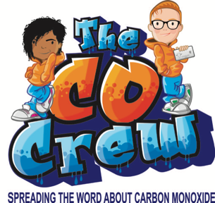

Carbon Monoxide (CO) Awareness Initiative for Year 5 on Friday 24th October 2024

Dear Parents/Carers/Guardians,

We are writing to let you know about a very special safety session for your child. We are a company called Bonanza Creative and in collaboration with your local Gas Network we delivered a workshop called “The CO Crew”.
This interactive session uses games and drama to educate children on the dangers of carbon monoxide and how to keep themselves safe.

There is more information about CO in the carbon monoxide booklet that you will receive, or you can visit: https://www.thecocrew.co.uk

We are aware that safety information can be quite alarming for children and have therefore made a great effort to package all the information in a child-friendly way. That said, if your child does have any concerns about CO, please allay fears. It is highly unlikely that CO is present in your home but, nonetheless, we must work to educate ourselves about its dangers and take precautions to keep ourselves safe, such as fitting a CO alarm.

Thank you for your time and if you have any concerns, please don’t hesitate to get in contact with your child’s school.

Bonanza Creative

www.bonanza-creative.org

