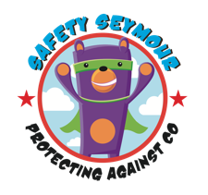
Carbon Monoxide (CO) Awareness Initiative

Dear Parents/Carers

We are writing to let you know about a very special safety session that is coming up.

Bonanza Creative will be delivering a workshop to your child’s class to educate them on the dangers of carbon monoxide (CO) and how we can keep ourselves safe. Safety Seymour, a superhero bear will be visiting your child’s class with his safety assistant, on a mission to rid the world of CO poisoning but he needs help!!

After the session, your child will be given an activity pack to take home with them. This includes:

- A CO information booklet. Please keep this for reference.
- Seymour’s adventure trail sheet. Please assist your child in this fun activity.
- Create your own Safety Seymour 3D figure.
- A certificate congratulating them on becoming ‘An Official Safety Assistant’.
- A Safety Seymour keyring.

We are aware that safety information can be quite alarming for children and have therefore made a great effort to produce this information in a child-friendly way to help reduce any worries. It is highly unlikely that CO is present in your home, educating ourselves and fitting a CO alarm are great preventative measures.

This programme has been fully funded by your local Gas Distribution Network.

For more safety information visit: safetyseymour.co.uk. It’s full of fun activities for your child to take part in.

Thank you.



