As Historians, we will be exploring events beyond living memory that are important globally, including the hero’s story of Nelson Mandela.
As Geographers, we will be learning key physical and human geographical features of our local area and features of African comparative locations. We will also be studying a range of maps and drawing our own as well.
As Scientists, we will be exploring local habitats close to home, including our local mini-beasts, as well as habitats right around the world and how these support all the animals and plants who live in them

On Safari
Summer Term 1 2026
Areas of Learning

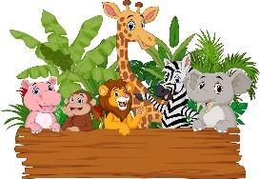
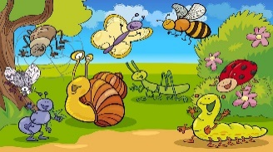

Puffin Class - Year 1 & 2

- Functional Writing: Letters and Postcards home
- Imaginative Writing: narrative story writing about our safari adventures
- Phonics & Spelling will be linked to our Phase 5 (Y1) and Phase 6 (Y2) Phonics learning including speedy sounds, common exception words and dictations
- Punctuation and grammar – exploring different sentence types marked by their punctuation, adding a range of suffixes and identifying word classes (verb, noun, adjective, adverb, conjunction)
- In reading we will be working on tasks linked to our class texts - One day on Our Blue Planet, In the savanna and The Ugly Five.

In class, we will discuss robots and different ways they are used and learn how simple robots can be operated using buttons and the children will develop the skills to programme a robot with a series of inputs to achieve a desired outcome

- Recognise, find and name half as two equal parts (Y1)
- Recognise, find and name a quester as four equal parts (Y1)
- Count in 2’s, 5’s and 10’s (Y1)
- Make equal groups (Y1)
- Make arrays (Y1)
- Find simple fractions of amounts (Y2)
- Recognise basic equivalence (Y2)
- Recognise coins and notes (Y2)
- Count money (Y2)
- Tell the time (Y2)

Problem Solving and Reasoning will be linked each week to the Maths skills we are learning.

We will be developing our maypole dancing ahead of our May day celebrations. The children will be working to develop timing, skills and performative attributes whilst learning a choregraphed dance ready to share it with you all at the end of term.

ENGLISH
Computing

PE
MATHEMATICS

MUSIC

Exploring contrasts in music of different types and begin to compose our own music with a range of musical devices, instruments and voice sounds.

00

We will have French lessons every Tuesday afternoon with Mrs Ziebeck, when they will learn a variety of French greetings, words, phrases, numbers and songs.

We will be learning about
how stories and art help us to understand different world views and religions; studying a range of stories and different forms of art across a range of religions to help better understand them and their importance

FRENCH
RE

Bledington Flower Show (11th April)
World Mental Health Week (11th May)
SATS 11th May – 15th May
Maypole (22nd May)

We will continue to stress the importance positive attitudes to study using the gross mindset techniques; learning how to maximise our learning through focus, effort and deliberate practice. We will also work as a team, helping everyone to learn more. House points will be awarded for demonstrating responsible behaviour.

.
We will deepen our understanding of this term’s school value Wisdom
Continue with the PINK curriculum in the Rainbow Room.
Working on paired and team work (importance of co-operation and communication)

Walk to school week, exploring ways to support and explore our community
Taking part in the local community flower show
Bledington Village Fete (6th June)
Enrichment
Learning to Learn Skills

PSED

Community

Class

