Mental Health Support Services
  Rethink Mental Illness – Self Harm Support  0808 801 0606  Or text 07537410 022  http://www.gloucestershireselfharm.org  or  www.rethink.org | Our Gloucestershire Self Harm Helpline provides a safe, supportive, non-judgmental and informative space for people who self harm, their friends, families and carers. We also speak to professionals who may want to know more about self harm. The service is able to support anyone living within Gloucestershire, and you can contact the service by telephone, text or webchat during our opening hours, every day 5pm to 10pm.
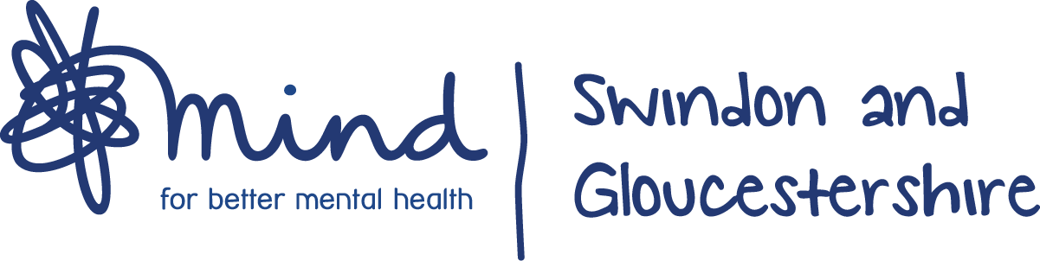  01452 245338  www.sgmind.org.uk  or email  alexwellbeing@sgmind.org.uk | We provide advice and support to empower anyone experiencing a mental health problem. We campaign to improve services, raise awareness and promote understanding. We won't give up until everyone experiencing a mental health problem gets support and respect.  www.mind.org.uk – this website provides an A – Z of mental health topics.
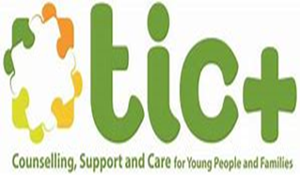  www.ticplus.org.uk  01594 372777  Or text  07520 634063  Parent Support & Advice line offers online chat  0800 6525675  https://ticplus.org.uk/parents-carers/parent-and-carer-support/ | Online or telephone counselling for children and young people  At TIC+ we’re here to support children and young people aged 9-21 and their families.
www.ghc.nhs.uk/crisis  0800 169 0398 | NHS online services available to support with mental health.
https://www.onyourmindglos.nhs.uk/  | We found that children and young people want to know what help and support is available to them locally and nationally. They want to know how they can help themselves and which websites they can trust. That is why we have created the ‘On your mind’ website. We hope that this website will mean that you are able to get help when you need it and also do things to make yourself stronger, so you are more able to cope when things are tough.
  www.samaritans.org/branches/gloucester/  116 123 (free)  Or  0330 0945717 (Local Rate) | Whatever you're going through, a Samaritan will face it with you. We're here 24 hours a day, 365 days a year.
  https://www.infobuzz.co.uk/mental-health/  01452 501 008 | Infobuzz offer a range of services to support people to improve their mental health. Hover over the mental health banner in the menu above to see a full list of services available. Or please get in touch to discuss specific needs
  Young Gloucesterhire  https://www.youngglos.org.uk/young-people/mental-health/linked-up-project  01452 501008  Email hello@youngglos.org.uk | You might not be sure if you need help with your 'mental health', you might just be feeling a bit blue or overwhelmed. Or perhaps you have received a diagnosis and you don't know what happens next. Linked Up is able to offer practical and emotional support.  The project works with 16-25 year olds facing challenges with their mental and emotional wellbeing. If your mental health is starting to have an impact on your day-to-day life, it may be a good time to get in touch.
SHOUT  https://www.giveusashout.org/  Text Shout to 85258 | Shout is the UK’s first 24/7 text service, free on all major mobile networks, for anyone in crisis anytime, anywhere. It’s a place to go if you’re struggling to cope and you need immediate help.  Shout is powered by a team of volunteers, who are at the heart of the service. We take people from crisis to calm every single day.
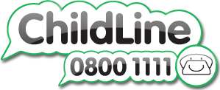 | A message from Childline  It can be difficult to cope when there’s so much changing around us. You might be worried about schools closing, friends or relatives getting ill or what'll happen in the future.  Childline and our counsellors want to support you through this. We’re working hard to make sure you can still speak to a counsellor when you need to.
  https://www.themix.org.uk/get-support  or  0808 808 4994 | The Mix are always here to help young people with any issue they’re facing, and at this challenging time, our services are more needed than ever
 https://youngminds.org.uk | We’re leading the fight for a future where all young minds are supported and empowered, whatever the challenges. We’re here to make sure they get the best possible mental health support and have the resilience to overcome life’s difficulties.
  https://papyrus-uk.org | HOPELINEUK is a confidential support and advice service for:  - Children and Young People under the age of 35 who are experiencing thoughts of suicide  - Anyone concerned that a young person could be thinking about suicide
  https://www.annafreud.org | The Anna Freud National Centre for Children and Families is a children’s mental health charity with over 60 years’ experience of caring for young people and their families. Our vision is a world in which children and their families are effectively supported to build on their own strengths to achieve their goals in life.
https://www.bigwhitewall.com | People come to Big White Wall for support with a wide range of mental health and wellbeing issues – from anxiety, depression, isolation and stress, to relationship problems and lifestyle challenges. The safety of our members and clinical rigour is at the core of what we do and we have a network of trained professionals providing 24/7 support around the world
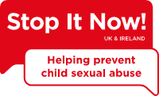  https://www.stopitnow.org.uk/  or  call 0808 1000 900 (9am-9pm Monday-Thursday, 9am-5pm Friday). | Our confidential Stop It Now! Helpline is available to anyone with questions or concerns about child sexual abuse prevention, including parents and professionals
  The Music Works https://www.themusicworks.org.uk/young-person/mental-health/ | Music can have a massive impact on your state of mind. For many people, it can help them to cope with stressful times and with mental health problems like depression and anxiety
  https://www.cotswold-counselling.org.uk/ | Counselling provides the opportunity to talk in confidence to someone who is trained to listen. Counselling can help make sense of what you are feeling about difficulties you are experiencing in your life at this time.
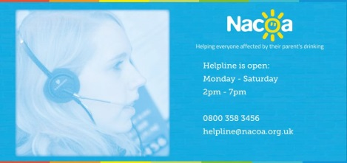  https://www.nacoa.org.uk/  0800 358 3456 | Providing information, advice and support for everyone affected by a parent's drinking
https://www.thedoor.org.uk/ | The Door's mission is to bring hope into the lives of young people and their families, through unlocking potential and opening opportunity so their past does not define their future.
  https://www.nhs.uk/oneyou/every-mind-matters/ | Having good mental health helps us relax more, achieve more and enjoy our lives more. We have expert advice and practical tips to help you look after your mental health and wellbeing.
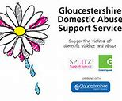  01452 726561  http://www.gdass.org.uk | A county-wide service designed to reduce the level of domestic abuse and improve the safety of victims and their families. We operate in all districts offering a variety of support programmes for women and men over 16 years old who are experiencing domestic abuse.
  https://www.independencetrust.co.uk/node/18  01452 317460 | We're here to support people who are experiencing moderate to severe Mental Ill Health. The service can be tailored to help support you to build on your strengths and to make a positive change.
  http://www.sunflowerssuicidesupport.org.uk/ | Suicide prevention and bereavement support
Mindfulness Apps
- Headspace
- Calm
- Smiling mind
- Mindfulness daily

Top 20 apps for Kids: https://mindbe-education.com/top-20-mindfulness-apps-kids/

Young people & anxiety App: https://healthyyoungmindspennine.nhs.uk/resource-centre/apps/

